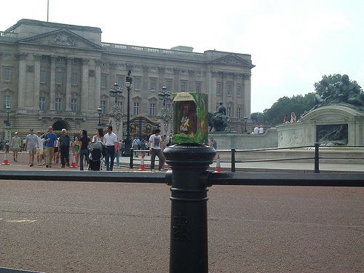

Image supplied courtesy of ELTPics
http://www.flickr.com/photos/54942754@N02/5748469836/in/photolist-9KYpNU-9KYpyy-9Bisgx-9KVAcc-cKfTLw


