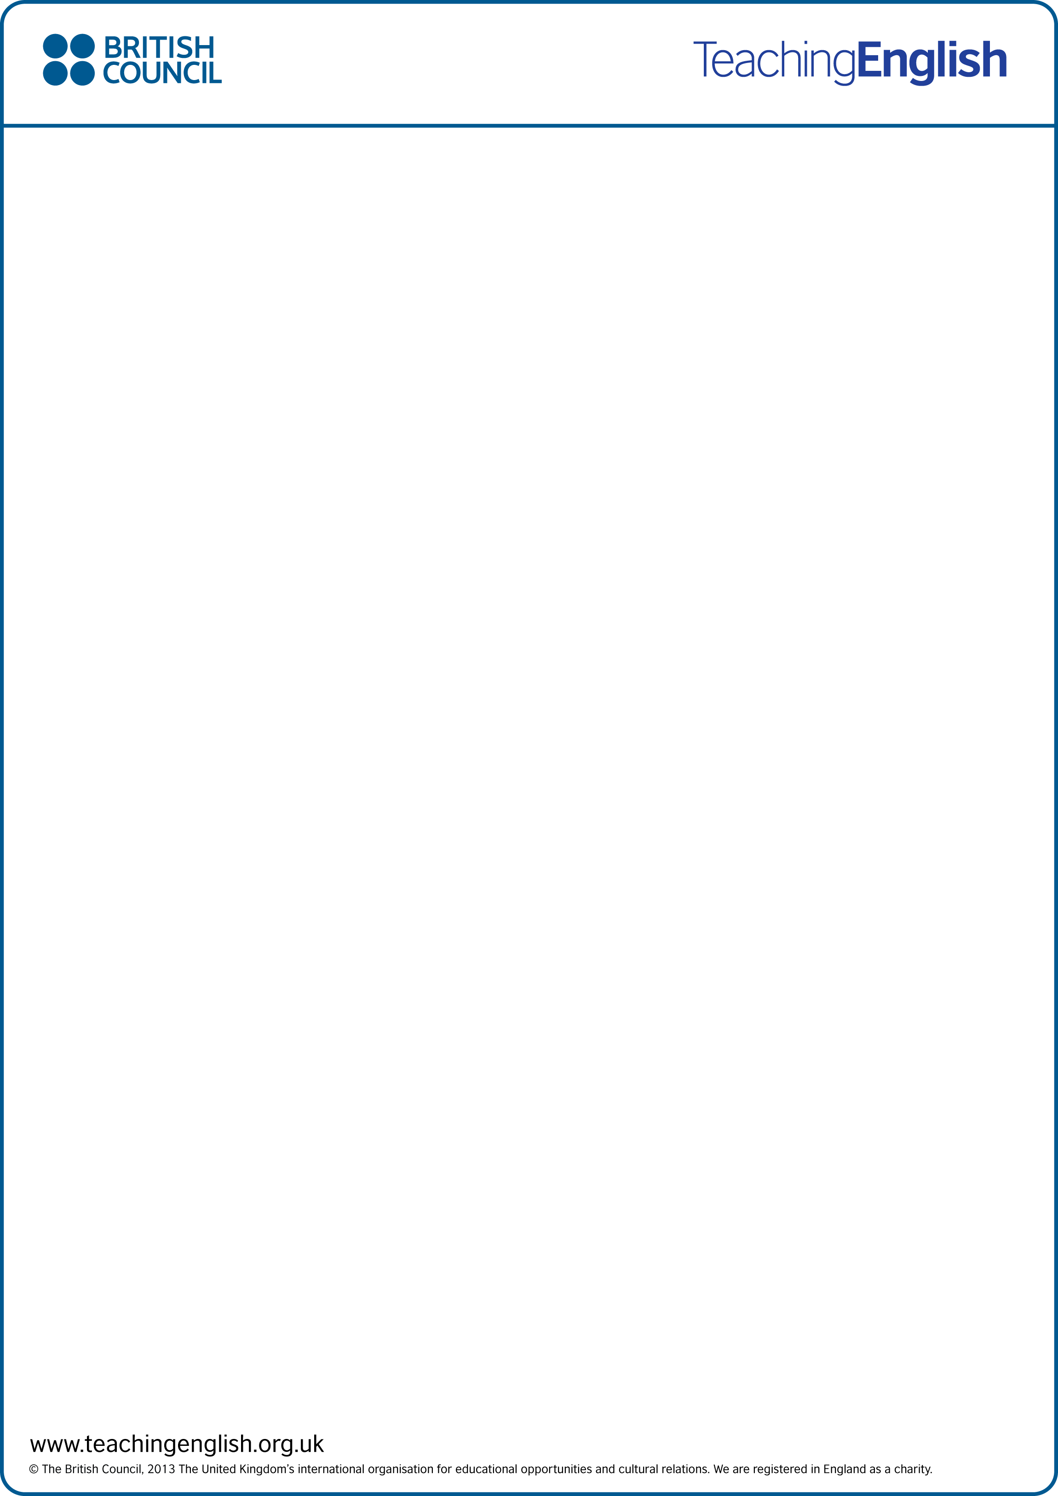

**Homework**

Circle five words to describe the giant panda

|  |  |
| --- | --- |
| Big  Green  Ugly  Popular  Furry | Strong  Cute  Endangered  Small  Scary |

Name: _____________________________

Write two sentences to describe the giant panda:

1. The giant panda is ____________________________________________________________
2. _____________________________________________________________________________